Masonic Charitable Foundation: Building better lives
15 minute script
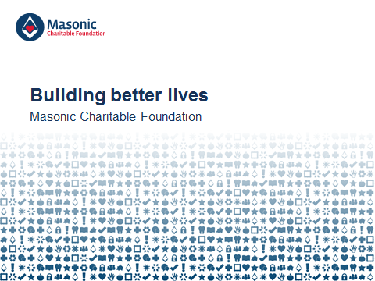
Good morning/afternoon/evening. My name is XXX and I am delighted to be here this evening to speak to you on behalf of the Masonic Charitable Foundation, a charity funded by Freemasons across England and Wales helping the most vulnerable people in society to live happy, fulfilling lives.
I want to begin this evening by telling you a story – a story about a man called Tom.
If you’d asked Tom to describe himself a few years ago, he might have told you he was a keen cyclist, a die-hard rugby fan or a hard-working painter and decorator. He certainly would have told you that he was a doting father to twin daughters, Emma and Sophie, and a loving and supportive husband to his wife, Clare – because, for Tom, family was everything.
Then, in 2014 – when Emma and Sophie were only six years old – Tom was diagnosed with Multiple sclerosis, a condition which has stripped him of his mobility.
As if that wasn’t enough, one by one the illness took away all the things that made him ‘Tom’. He could no longer ride his bike at the weekends or chant along with the crowds at rugby matches, and he had to quit his job. Eventually and most crucially, he could no longer play with his daughters, and had to watch as Clare struggled to care not only for the girls, but for him as well.
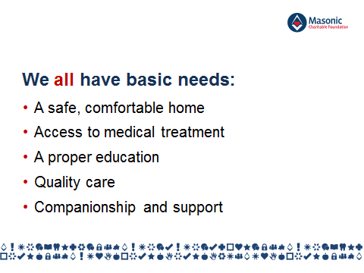
We all have basic needs that must be fulfilled in order for us feel like an active part of society. We need a home where we feel secure, comfortable and safe. If we fall ill, or when we grow old, we have need quality care and medicine. Our children need a proper education and opportunities that allow them to reach their full potential. And, whatever our age or circumstance, we need a network of people around us for companionship and support.
Tom’s diagnosis meant that his basic needs, and the basic needs of his family, could no longer be fulfilled.
He no longer had a safe, comfortable home. Without his income, he and Clare worried they would not be able to make ends meet. The benefits they received from the government were enough to cover the basics, but they didn’t have any real quality of life as a family. They certainly didn’t have enough to adapt their house for Tom’s new mobility needs and instead he had to live downstairs in the dining room, with Clare facing a daily struggle to help her husband in the bathroom and in and out of bed. The local council provided funding for an electric wheelchair, but it was too wide to fit through the doorways in their home.
The optimum medication Tom needed to ease his symptoms was not available on the NHS, and as the family could not afford to access it privately, Tom simply had to go without.
And it was not just Tom and Clare that were affected. With money so tight and Clare so busy looking after Tom, school trips and extra-curricular activities were out of the question. Emma was no longer able to attend the gymnastics lessons she loved and Sophie stopped learning to swim. Tom had always wanted the best for his girls, but his illness meant they were missing out on opportunities to learn and grow.
Tom’s illness also meant the family’s time together would not only be devastatingly short, but also full of worry about far more than Tom’s health alone.
We are very fortunate that in this country, most people have a stable, comfortable home, quality care, medical treatment, an education for our children, but you only have to pick up a newspaper or turn on the television to realise that many cases do not. The needs of many people like Tom and his family are simply not being met.
Across England and Wales, there are thousands more people who are worried about how they are going to make ends meet this month. There are people facing NHS waiting lists that stretch months, even years, into the future. There are elderly people who are confined to the ground floor of their homes because they can’t use the stairs any longer, many of whom go days at a time without speaking to another person. And there are children whose futures are being jeopardised because their parents can’t afford to give them the same basic opportunities as their school friends.
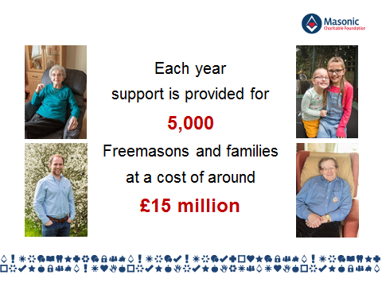
For people like this – both within and beyond the Masonic community – we, the Masonic Charitable Foundation, are here to help. Every year, we support 5,000 Freemasons and their families across England and Wales at a cost of £15 million, and impact the lives of tens of thousands more in wider society through £5 million in grants to other charities.
For members of our Masonic family, we provide a combination of financial grants and practical support to help ensure that everyone’s basic needs are met.
Our grants for Freemasons and their families fall into four areas – financial, health, family and care.
Our financial grants support those who, due to a change in their financial situation, are unable to afford essential everyday costs, such as household bills or food. Some of these people have experienced redundancy, the death of a partner, family breakdown or – as was the case with Tom – a life-changing medical diagnosis that means they are no longer able to work.
We provide grants to top up other sources of income so that families can stop worrying about how they will pay the bills. It’s also important to us that families are able to actively participate in society and enjoy quality of life and happiness, so we make sure to include a reasonable allowance for leisure activities. Our support not only meant that Tom and Clare could feel financially secure in their own home; it also allowed the family to enjoy some cherished days out together that the girls will remember long after their father has died.
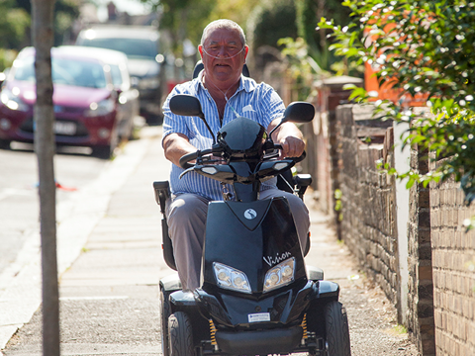
Our health grants support Freemasons and their family members who have a diagnosed medical need, face a lengthy wait for NHS treatment and cannot easily afford private treatment. In Tom’s case, the treatment he needed was not available on the NHS at all, but we made sure that he could access it as quickly as possible. Our health grants cover some or all of the cost of private treatment so that you can access what you need, when you need it.
We also provided Tom with a slim-line powered wheelchair, a stairlift and covered some of the cost of converting his bathroom into a fully-accessible wet room. It’s important to us that those with limited mobility are able to retain their independence, so we provide mobility aids including wheelchairs and scooters, and can cover essential home adaptations including stairlifts, entry ramps and car hoists.
Alongside grants for physical needs, we also provide a Counselling Careline service to support the emotional wellbeing of Freemasons and their families. The Careline is a confidential, free helpline operated by a professional, independent team of trained counsellors. It can support those who are experiencing depression or anxiety, as well as those who may be simply going through a difficult time in their life due to workplace pressures, bereavement, family breakdown, financial hardship or illness. Due to the confidential nature of the Careline, we don’t know if Tom or Clare used the service – but it is certainly suitable if you have been affected by a medical diagnosis or have the responsibility of caring for a family member.
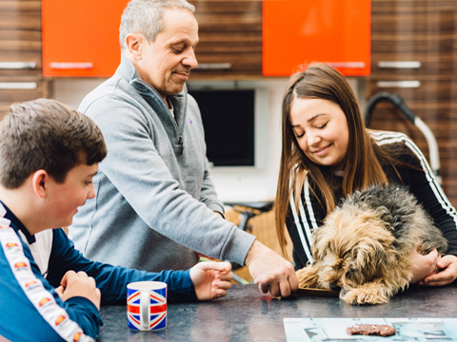
For families who are receiving daily living grants, we can also provide family grants to make sure children in full-time education can continue their education without disruption and meet their full potential despite difficulties they may be experiencing at home.
I mentioned the impact Tom’s diagnosis had on Emma and Sophie – children are often those most affected by family or other events. The added pressure on the family can put their quality of life and happiness at risk, as well as their ability to access opportunities and meet their full potential.
We can cover the full or partial cost of items such as computers, printers and school uniforms, as well as specialist tuition and extra-curricular activities so that children have access to the same resources as their classmates.
Our support meant that Emma and Sophie could resume the gymnastics and swimming lessons they so enjoyed, and Tom and Clare could take comfort that – despite such difficult circumstances – the girls’ education was not being compromised.
If necessary, our support for a child’s education can be provided from nursery all the way through to university when scholarships and accommodation grants can be awarded.
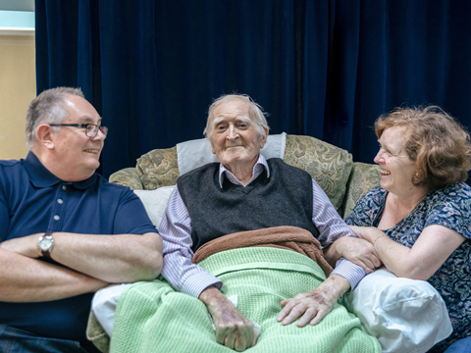
We can also support a wide range of care needs. In cases where a full-time carer is in need of a break from their duties for their own physical and mental wellbeing, respite care grants can help meet the cost of short-term residential breaks, domiciliary care in an individual’s own home or visits to day centres. Respite is vital to provide support and relief for those caring for family members. We fund visits from a trained carer for Tom to relieve some of the pressure that Claire faces as a full-time carer.
For those with more permanent care needs, we provide Masonic care homes and other services at 17 locations across England and Wales that offer residential and nursing care. All provide specialist support for those living with dementia. Over 1,000 residents currently live in our care homes, including many older Freemasons and their family members. Those members of the Masonic community who choose to live in one of our Homes have the security of knowing that they have a home for life, even if their financial circumstances change for the worse.
As you can see, we provide a wide range of grants for Freemasons and their families experiencing a financial, health or family need, but our support goes far beyond financial grants. Members of the Masonic family at any age can also draw on the expertise of our Advice & Support Team who offer confidential, impartial and practical guidance about the help available and the application process. A member of the Team visited Tom and Clare at home and helped them to apply for the state and local authority benefits to which they are entitled, provided advice about respite care options and the girls’ education, and recommended other organisations that have provided them with further assistance.
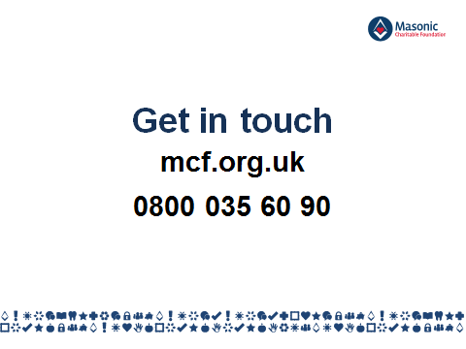
Our support for Masonic families, whether through grants or practical guidance, continues for as long as the family needs us. I’ve talked a lot about Tom and Clare’s family so far this evening, but I want to stress to the members of the Masonic community that are here this evening: our wide range of support is here for you. If you or someone you know needs help, I urge you - please contact your Lodge Almoner or the charity directly, visit the our website (mcf.org.uk) or give us a call on our free enquiry line.
Let’s refer back for a moment to those basic needs that every person has: a home, quality care, medical treatment, an education, and support networks. For every member of the Masonic community who does not have one or more of these building blocks for a happy, active life, there are hundreds, if not thousands more in wider society.
Masonic charity was established almost 230 years ago to support Freemasons and their families in need of support, and the tradition of Freemasons giving to their local communities developed across the same period. In the last four decades alone, through the central Masonic charities, Freemasons in England and Wales have given over £130 million to other charities and causes. At the root of this extraordinary generosity lies one of the basic principles by which all Freemasons conduct their lives – an ingrained duty to care for those who are less fortunate. It is thanks to this generosity that we at the MCF will continue to award around £5 million to such local and national charities every year.
Many of you may be aware of our regular financial support for hospice services and rescue services – in the XXX we have provided £XX,000 in support to your hospice services since the 1980s as well as £XX,000 to XXX. But are you aware that many of the charities we support tackle the same issues in wider society that we help with directly within the Masonic community?
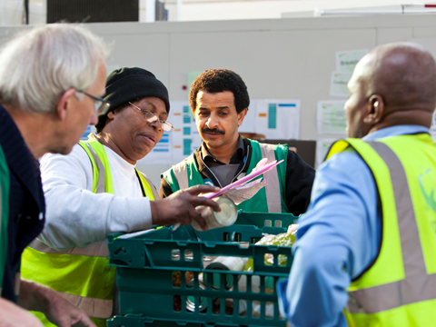
For example, we gave grants to Tom and Clare to ensure that they could keep on top of their essential outgoings, and many of the charities we support provide services for people in wider society who are in poverty, debt or unemployment. For example in the last year we have funded a number of foodbank projects that distribute surplus food to elderly people, single-parent families and other vulnerable people across England and Wales.
And in the same way that we covered educational costs for Emma and Sophie, others charities that we support provide opportunities in education or employment for vulnerable children and young people who, due to financial hardship, special educational needs or family circumstances outside of their control, are unable to access the same opportunities as their friends. We regularly fund charities that use sport and other group activities to teach skills such as teamwork as well as charities that provide mental health services for young people. This year, we awarded a £240,000 grant to Achievement for All which will fund educational programmes for disadvantages children in schools in every Province, including this one.
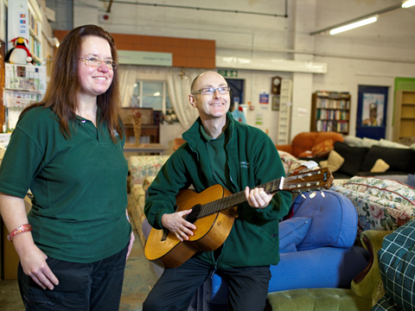
Some of the charities we support provide services for those who are excluded from society and face barriers to becoming an active member of society – for example we fund many projects that work with homeless people, older people and family carers like Clare.
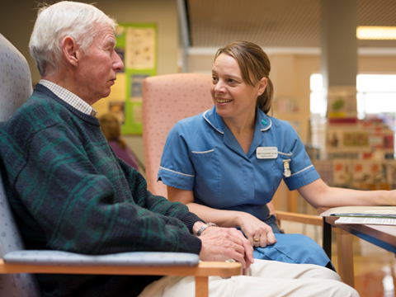
And in the same way that we provided access to medical care, home adaptations and mobility equipment for Tom after his MS diagnosis, we also support other people in society living with the condition through our support for charities such as the Chiltern MS Centre – we recently awarded a £30,000 grant to fund their specialist physiotherapy service which is improving the health and well-being of people affected by multiple sclerosis. Other charities we fund support people of all ages living with, for example, blindness, deafness, Alzheimer’s, dementia, cancer and mental health conditions. Recent grants have included £25,000 to Arthritis Care, £60,000 to Dementia UK and £45,000 to Jo's Cervical Cancer Trust.
And our work related to medical conditions and disability goes one step further – we also invest millions in the future of the Masonic family and wider society through funding for medical research into a wide range of conditions, including cancer, heart disease, arthritis, degenerative eye disease and, most relevant to Tom and his family, MS. We have funded medical research at the University of Cambridge to advance understanding of multiple sclerosis, giving hope to Tom and other people living with MS. As you can see, we’re not just attending to the symptoms – we’re helping to fund new, more effective treatments.
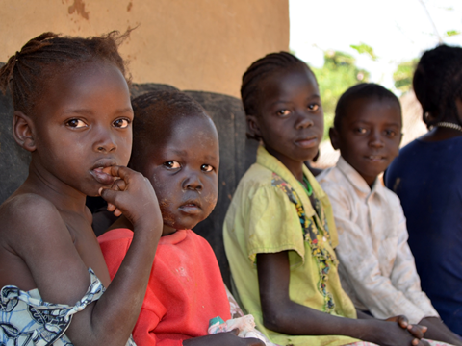
Where possible, we extend our support to those in need of help outside England and Wales – we are always among the first to respond to appeals for disaster relief, and in the last year we contributed £55,000 to relief efforts following Hurricane Matthew and £100,000 to help distribute food packages and water purification tables to families affected by the East Africa food crisis.
I hope that you can see that through our Charity Grants we aim to give the most vulnerable, disadvantaged people across England and Wales and beyond the tools and opportunities they need to live the happiest, safest, most fulfilling life possible. In XXX, we have given £XX,XXX to XXX charities including XXX.
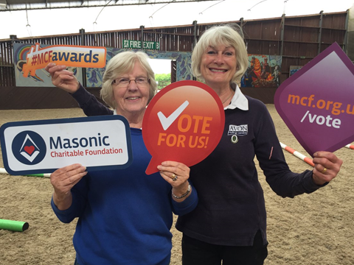
Last year, to celebrate the 300th anniversary of the United Grand Lodge of England, we awarded an additional £3 million to 300 charities across England and Wales. Freemasons in every Province nominated a number of local charities to receive a grant, and in this Province those charities were:
- XXX
- XXX
- XXX
- XXX
Each of these charities received between £4,000 and £25,000, depending on how many votes they received. This was the first time that we asked the public and the Masonic community to decide how we distributed our funds and was highly successful in demonstrating to the public the charitable work carried out by Freemasons.
I’ve covered a lot of information in the last few minutes, but I want to pause for a just a moment and ask you to imagine...
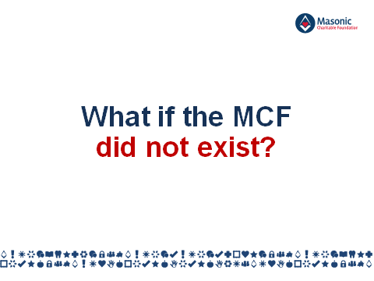
...a world where the MCF doesn’t exist. I know what some of you are thinking – you probably didn’t even know about the MCF before this evening, so would society be that different without us? Well, let me put it into perspective by looking at the past year.
If the MCF did not exist, over the past 12 months, 5,000 Freemasons and their family members would have lacked the basic elements of a happy, fulfilled life. That ‘5,000’ equates to:
- 1,028 people struggling to pay their monthly bills after an unexpectedly reduced income;
- 1,190 people either still waiting for NHS treatment, unable to access the treatment they need at all, or losing their independence because of the cost of mobility aids like wheelchairs and stairlifts;
- 1,426 children missing out on opportunities at school and being left behind by their peers because their parents simply cannot afford the costs related to their education; and
- 792 families anxiously trying to find alternative care for their loved ones because their funding has run out.
- Just to bring it a little closer to home, without the MCF, XX of your Brethren and their family members in this Province would have gone without the support they needed.
Looking at wider society, if the MCF hadn’t existed over the last 12 months:
- 137 charities operating across England and Wales would be £3 million worse off in what is a competitive fundraising environment, and would be unable to provide their life-changing services to tens of thousands of vulnerable children, young people and adults;
- 9 pioneering medical research studies would lack £1 million in funding, potentially impacting the futures of hundreds of thousands of people living with – or yet to be diagnosed with – a wide range of medical conditions;
- 245 hospice services and 49 air ambulance and rescue services would have had to raise a total of £800,000 from other sources instead of focussing on their vital work.
That’s a lot of numbers, so let’s go back to the story I told you at the start of this talk.
If the MCF didn’t exist, Tom and Clare would probably have lost their home. Even if they had somehow managed to keep up with mortgage payments with only one income, they wouldn’t have been able to make their home suitable for Tom’s mobility needs. He would have had to continue sleeping on a makeshift bed in the dining room, away from his family, slowly losing his independence because his wheelchair was too wide to move from room to room and suffering more than necessary from the debilitating symptoms of his illness because the treatment he needed was not available on the NHS. While this would be absolutely terrible for Tom, Clare too would suffer because without the funds to afford respite care, she would have to shoulder full the responsibility for caring for him and thir girls alone, day in, day out.
Tom and Clare would have struggled to afford the essentials for Emma and Sophie like new school uniforms and a computer let alone small luxuries like school trips and after-school clubs. They would have been forced to say no to educational opportunities despite wanting to give their girls the best start in life – something that all parents want for their children.
Fortunately for Tom and his family, the other 5,000 Freemasons and family members we support and the tens of thousands of people supported by the charities we fund – the MCF does exist.
But we don’t exist without the Masonic community, many of whom are in this room tonight.
To those Freemasons, I say: if you are able to support our work financially, please donate.
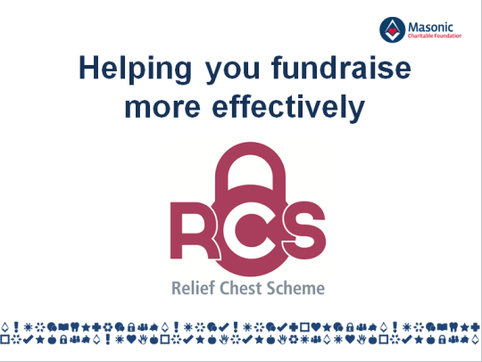
When it comes to fundraising, the Relief Chest Scheme allows individuals, Lodges and Provinces to save time, take control and give more to the charities they support. You can find out more about the Relief Chest Scheme on the MCF website.
To those here this evening who are not Freemasons, and those who aren’t able to donate, you can still help by telling people about the MCF and by ensuring that all those that need assistance know where to turn in their hour of need.
And finally, if you think you might require support for a financial, health, family or care-related need, or know of someone that may be, please don’t hesitate pick up the phone and call us.
Right Worshipful Provincial Grand Master, Ladies, Gentlemen and Brethren thank you for listening and thank you again for your support.

