To find Provincial statistics for this speech (page 15 and 17), visit:
mcf.org.uk/impact/our-work-in-your-community

Masonic Charitable Foundation: Building better lives
15 minute script
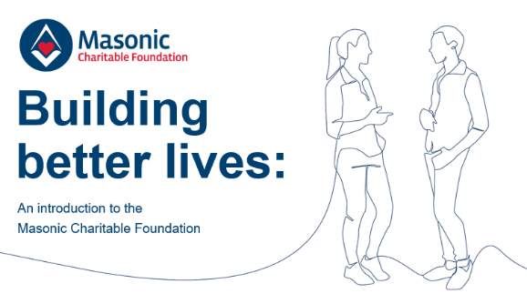
Good morning/afternoon/evening. My name is XXX and I am delighted to be here this evening to speak to you on behalf of the Masonic Charitable Foundation, a charity funded by Freemasons across England and Wales helping the most vulnerable people in society to live happy, fulfilling lives.
I want to begin this evening by telling you a story – a story about a family.
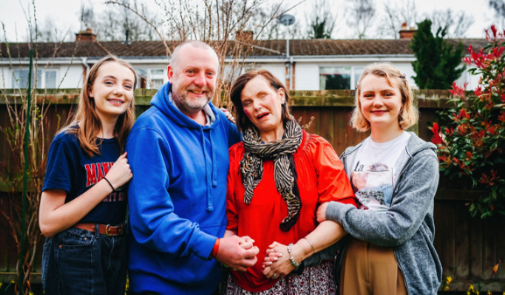
If you’d have asked Mark, his wife Jacqui, and their two girls Ella and Grace to describe their lives a few years ago, they might have said that they were a happy, outgoing family unit.
The girls adored trampolining, spending time with friends, and developing their hobbies, and Mark and Jacqui enjoyed watching them grow.
The family’s love for one another was everything.
Then, driving home from work one ordinary evening, Jacqui was involved in a devastating car crash that left her with permanent and life-altering brain injuries.
As she fought for her life, her two girls and loving husband watched on as their world changed forever.
As if the trauma of seeing their wife and mum battle against the odds wasn’t enough, when Jacqui began to recover, it became clear that the accident had taken away many of the things that made her ‘her’.
Sadly, as a result of her brain injury, Jacqui can no longer live independently, and her personality has completely changed.
She now lives full-time in hospital, where her complex care needs can be met by the round-the-clock staff.
I can only imagine what the girls and Mark were feeling when they had to return to their home without their wife and mum, and figure out how life was going to be now everything had changed.
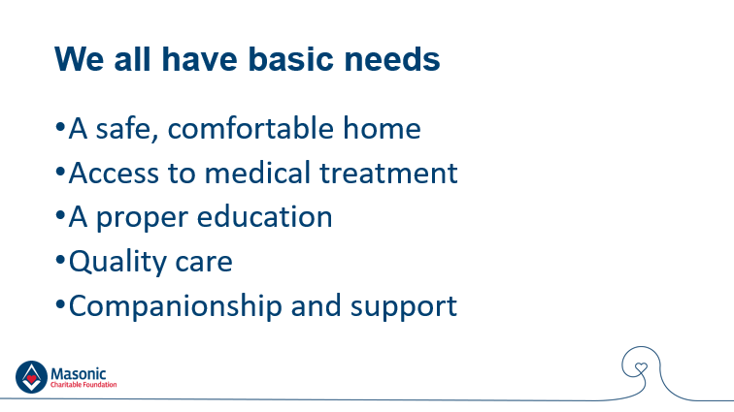
We all have basic needs that must be fulfilled in order for us feel like an active part of society.
We need a home where we feel secure, comfortable and safe.
If we fall ill, or when we grow old, we need quality care and medicine.
Our children need a proper education and opportunities that allow them to reach their full potential.
And, whatever our age or circumstance, we need a network of people around us for companionship and support.
Jacqui’s injury meant that her needs, and the basic needs of her family could no longer be fulfilled.
They no longer had a safe, comfortable home.
Without Jacqui’s income, Mark worried about how he would be able to make ends meet.
Could they have any real quality of life as a family?
With money so tight and the cost of travelling to and from Jacqui’s hospital so high, school trips and extra-curricular activities were beginning to look out of the question.
The girls would simply have to go without.
Ella and Grace’s opportunities began to slip away from them.
Mark and Jacqui had always wanted the best for their girls, but this unexpected reduction in their family’s income meant they were missing out on opportunities to learn and grow.
It was becoming clear that Jacqui’s injury meant the family’s time together would be full of worry about far more than her health alone.
We are very fortunate that in this country, most people have a stable, comfortable home, quality care, medical treatment, and an education for their children, but you only have to pick up a newspaper or turn on the television to realise that many people do not.
Across England and Wales, there are thousands more people like Mark who are worried about how they are going to make ends meet this month.
There are people facing NHS waiting lists that stretch months, even years, into the future.
There are older people who are confined to the ground floor of their homes because they can no longer climb the stairs, many of whom go days at a time without speaking to another person.
And there are children like Ella and Grace whose futures are being jeopardised because their parents can’t afford to give them the same basic opportunities as their school friends.
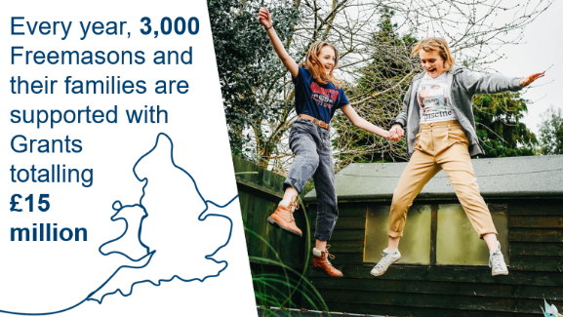
For people like this – both within and beyond Freemasonry’s community – we, the Masonic Charitable Foundation, are here to help.
Every year, we support 3,000 Freemasons and their families across England and Wales at a cost of £15 million, and impact the lives of tens of thousands more in wider society through £5.5 million in grants to other charities.
For Freemasons and their families, we provide a combination of financial grants and practical support to help ensure that everyone’s basic needs are met.
Our grants for Freemasons and their families fall into five areas – daily living costs; health, care, and wellbeing; children, young people, and education; advice and support; and the Royal Masonic Benevolent Institute, or RMBI Care Co.
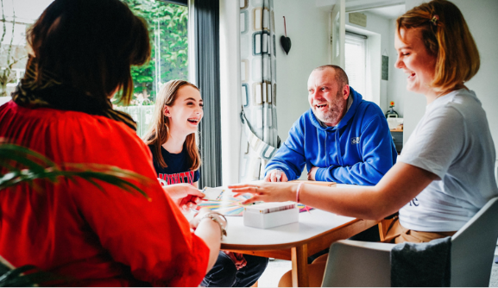
Our grants for daily living costs support those who, due to a change in their financial situation, are unable to afford essential everyday expenses – such as household bills or food – and unexpected costs –
such as funeral bills or emergency home repairs.
Some of these people have experienced redundancy, the death of a partner, family breakdown or – as was the case with Mark and Jacqui’s family – a life-changing injury that means they are no longer able to work.
We provide grants to top up other sources of income so that families can stop worrying about how they will pay the bills.
It’s also important to us that families are able to actively participate in society and enjoy quality of life and happiness, so we make sure to include a reasonable allowance for leisure activities.
Our support not only meant that Mark and the girls could feel financially secure in their own home; it is also allowing the family to spend cherished time together and make new, precious memories.

Our health, care, and wellbeing grants support Freemasons and their family members who have a diagnosed medical need, face a lengthy wait for NHS treatment and cannot easily afford private treatment.
Our health grants cover some or all of the cost of private treatment so that you can access what you need, when you need it.
It’s important to us that those with limited mobility are able to retain their independence, so we provide mobility equipment including wheelchairs and scooters, and can cover essential home adaptations including stairlifts, entry ramps and car hoists.
Alongside grants for physical needs, we also provide a counselling service to support the emotional wellbeing of Freemasons and their families.
The service is a confidential, free helpline operated by a professional, independent team of trained counsellors.
It can support those who are experiencing depression or anxiety, as well as those who may be simply going through a difficult time in their life due to workplace pressures, family breakdown, financial hardship or illness.
Due to its confidential nature, we don’t know if Mark or the girls used the service – but it is certainly there for them if they need it.
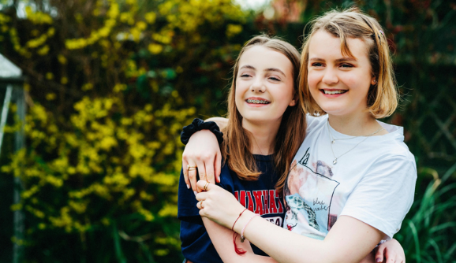
For families who are receiving grants to support daily living costs, we can also provide grants to make sure children in full-time education can continue their learning without disruption and meet their full potential despite difficulties they may be experiencing at home.
I mentioned the impact Jacqui’s brain injury had on Ella and Grace – children are often those most affected by traumatic family events.
The added pressure on the family can put their quality of life and happiness at risk, as well as their ability to access opportunities and meet their full potential.
We can cover the full or partial cost of items such as computers, printers and school uniforms, as well as specialist tuition and extra-curricular activities so that children have access to the same resources as their classmates.
Our support meant that Ella and Grace could resume the hobbies and school trips they so enjoyed, and Mark and Jacqui could take comfort that – despite such difficult circumstances – the girls’ education was not being compromised.
If necessary, our support for a child’s education can be provided from nursery all the way through to university when scholarships and accommodation grants can be awarded.

We can also support a wide range of care needs.
In cases where a full-time carer is in need of a break from their duties for their own physical and mental wellbeing, grants to provide breaks for carers can help meet the cost of short-term residential stays, domiciliary care in an individual’s own home or visits to day centres.
Breaks for carers are vital to provide support and relief for those caring for family members.
For those with more permanent care needs, we provide care homes and other services through the RMBI Care Co. at 17 locations across England and Wales that offer residential and nursing care.
All provide specialist support for those living with dementia.
Over 1,000 residents currently live in our care homes, including many older Freemasons and their family members.
Those members of Freemasonry’s community who choose to live in one of our homes have the security of knowing that they have a home for life, even if their financial circumstances change for the worse.
As you can see, we provide a wide range of grants for Freemasons and their families experiencing a financial, health or family need, but our support goes far beyond financial grants.
Freemasons and their family members at any age can also draw on the expertise of our Advice & Support Team who offer confidential, impartial and practical guidance about the help available and the application process.
A member can visit people in need and help them to apply for the state and local authority benefits to which they are entitled, provide advice about what we can offer, and recommend other organisations that can provide further assistance.
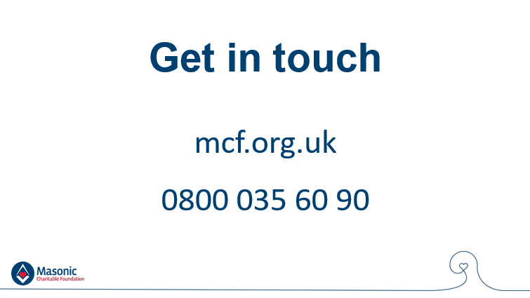
Our support for Freemasons and their families, whether through grants or practical guidance, continues for as long as the family needs us.
I’ve talked a lot about Mark and Jacqui’s family so far this evening, but I want to stress to the members of Freemasonry’s community that are here this evening: our wide range of support is here for you.
If you or someone you know needs help, I urge you – please contact your Lodge Almoner or the charity directly, visit our website (mcf.org.uk) or give us a call on our free enquiry line.
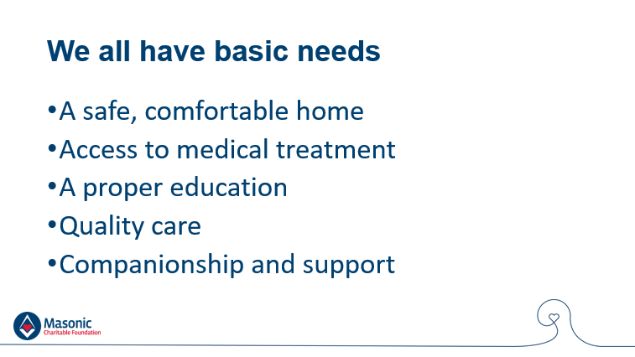
Let’s refer back for a moment to those basic needs that every person has: a home, quality care, medical treatment, an education, and support networks.
For every member of Freemasonry’s community who does not have one or more of these building blocks for a happy, active life, there are hundreds, if not thousands more in wider society.
Freemasonry’s role in charity was established almost 230 years ago to support Freemasons and their families in need of support, and the tradition of Freemasons giving to their local communities developed across the same period. To date, through Freemasonry’s central charities, Freemasons in England and Wales have given almost £169 million to other charities and causes.
At the root of this extraordinary generosity lies one of the basic principles by which all Freemasons conduct their lives – an ingrained duty to care for those who are less fortunate.
It is thanks to this generosity that we at the MCF continue to award around £5.5 million to such local and national charities every year.
But are you aware that many of the charities we support are tackling the same issues that we are dealing with in Freemasonry’s community?
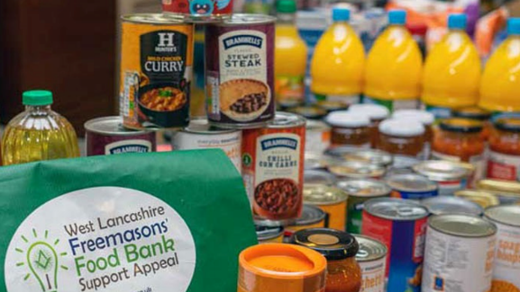
We gave grants to Mark and Jacqui’s family to ensure that they could keep on top of their essential outgoings, and many of the charities we support provide services for people in wider society who are in poverty, debt or unemployment.
For example, in the last year we have funded a number of foodbank projects that distribute surplus food to elderly people, single-parent families and other vulnerable people across England and Wales.
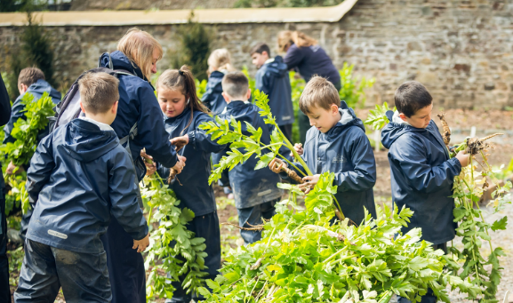
And in the same way that we cover educational costs for the children and grandchildren of Freemasons, others charities that we support provide opportunities in education or employment for vulnerable children and young people who, due to financial hardship, special educational needs or family circumstances outside of their control, are unable to access the same opportunities as their friends.
In 2020, we awarded a £250,000 grant to Buttle UK, a children’s charity that supports the education and wellbeing of young people in England and Wales.

Some of the charities we support provide services for those who are excluded from society and face barriers to becoming an active member of society – for example we fund many projects that work with homeless people, older people and family carers.

And in the same way that we provide access to medical care, home adaptations and mobility equipment for Freemasons and their families, we also support other people in society living with various medical conditions through our support for charities.
Other charities we fund support people of all ages living with, for example, blindness, deafness, Alzheimer’s, dementia, cancer and mental health conditions.
Recent grants have included £25,000 to Arthritis Care, £60,000 to Dementia UK and £45,000 to Jo's Cervical Cancer Trust.
And our work related to medical conditions and disability goes one step further – we also invest millions in the futures of Freemasons, their families, and wider society through funding for medical research into a wide range of conditions, including cancer, heart disease, arthritis, degenerative eye disease and, MS.
As you can see, we’re not just attending to the symptoms – we’re helping to fund new, more effective treatments that tackle the root causes.
Where possible, we also extend our support to those in need of help outside England and Wales – we are always among the first to respond to appeals for disaster relief, and were able to donate £30,000 to relief efforts following Hurricane Iota in Nicaragua and Honduras, supporting 884 families.

I hope you can see that through our charity grants we aim to give the most vulnerable, disadvantaged people across England, Wales and beyond the tools and opportunities they need to live the happiest, safest, most fulfilling lives possible.
In <province>, we have given £XX,XXX to XXX charities including XXX.
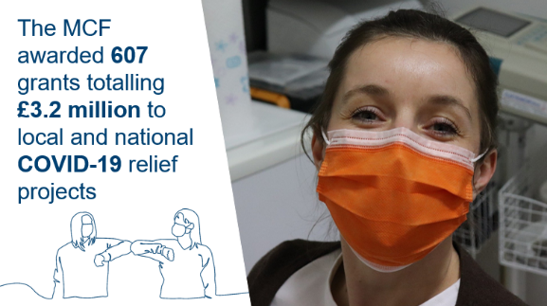
I’m not sure I could stand here and talk about the charitable efforts of Freemasons without mentioning the COVID-19 pandemic and the problems faced by individuals and communities across England and Wales.
Between 1 April 2020 and 31 January 2021, the MCF awarded an incredible 607 grants to local and national COVID-19 relief projects totalling a phenomenal £3.2 million.
Just over £1 million of that was donated to the MCF’s COVID-19 Community Fund by Freemasons and their family members in an astounding display of generosity.
And, as well as the usual system of charity grants, we helped Freemasons act as boots on the ground in their own communities, match-funding donations to their selected local charities.
This is yet another example of how the MCF – your charity – rises to challenges and helps Freemasonry make the world a better place.
I’ve covered a lot of information in the last few minutes, but I want to pause for a just a moment and ask you to imagine...
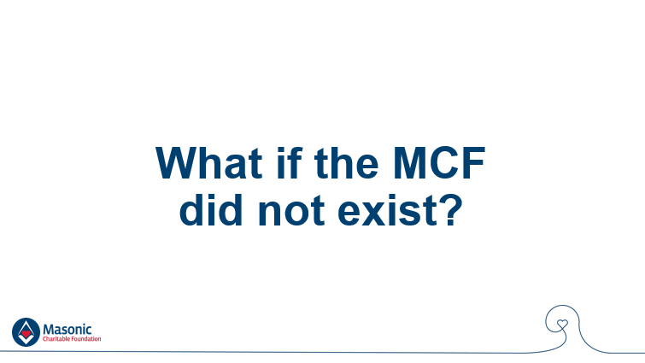
...a world where the MCF doesn’t exist.
I know what some of you are thinking – you probably didn’t even know about the MCF before this evening, so would society be that different without us? Well, let me put it into perspective by looking at the past year.
If the MCF did not exist, over the past financial year, 3,559 Freemasons and their family members would have lacked the basic elements of a happy, fulfilled life. That ‘3,559’ equates to:
- 2,273 families struggling to pay their monthly bills after an unexpectedly reduced income with grants totalling £8,442,307;
- 1,073 people either still waiting for NHS treatment, unable to access the treatment they need at all, or losing their independence because of the cost of mobility equipment like wheelchairs and stairlifts with grants totalling £2,364,001;
- 665 children missing out on opportunities at school and being left behind by their peers because their parents simply cannot afford the costs related to their education with grants totalling £1,757,071; and
- Just to bring it a little closer to home, without the MCF, XX of your Brethren and their family members in this Province would have gone without the support they needed.
Looking at wider society, if the MCF hadn’t existed over the last 12 months:
- Over 1,000 charities operating across England and Wales would be almost £8 million worse off in what is a competitive fundraising environment, and would be unable to provide their life-changing services to tens of thousands of vulnerable children, young people and adults;
- 219 hospice services would have had to raise a total of £800,000 from other sources instead of focussing on their vital work.
That’s a lot of numbers, so let’s go back to the story I told you at the start of this talk.
If the MCF didn’t exist, Mark and Jacqui’s family would probably have lost their home.
Even if they had somehow managed to keep up with mortgage payments with only one income, they wouldn’t be able to visit Jacqui in hospital regularly.
The hospital she lives in is a long way from the family home, and the cost of travel would mean the girls and Mark would rarely get to see their mum and wife, and she – far from home and the life she knew – would only occasionally get to see the people she loves.
While this would be absolutely terrible for the family as a whole, Ella and Grace would suffer especially too, because with money so tight, their education and development would begin to pay the price.
Mark would have struggled to afford the essentials for Ella and Grace like new school uniforms and a computer let alone small luxuries like school trips and after-school clubs.
He would have been forced to say no to educational opportunities despite wanting to give their girls the best start in life – something that all parents want for their children.
Fortunately for Mark and his family, the other 3,000 Freemasons and family members we support and the tens of thousands of people supported by the charities we fund – the MCF does exist.
But we wouldn’t exist without Freemasons and their families, many of whom are in this room tonight.
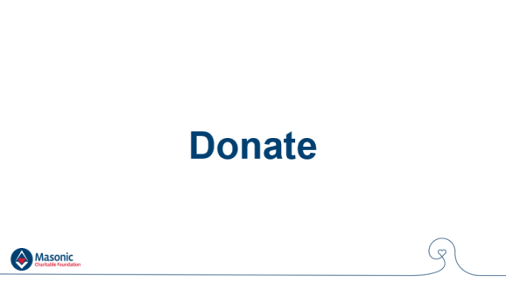
To those Freemasons, I say: if you are able to support our work financially, please donate.
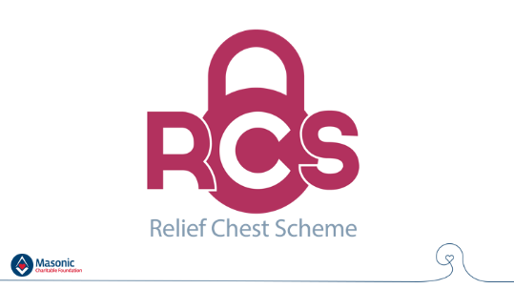
When it comes to fundraising, the Relief Chest Scheme allows individuals, lodges and Provinces to save time, take control and give more to the charities they support.
You can find out more about the Relief Chest Scheme on the MCF website.
To those here this evening who are not Freemasons, and those who aren’t able to donate, you can still help by telling people about the MCF and by ensuring that all those that need assistance know where to turn in their hour of need.
And finally, if you think you might require support for a financial, health, family or care-related need, or know of someone that may be, please don’t hesitate pick up the phone and call us.
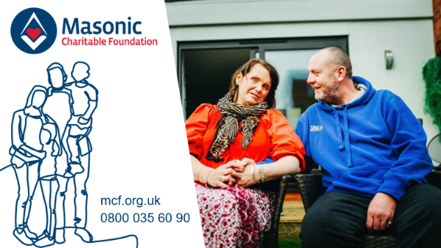
Ladies, Gentlemen and Brethren – thank you for listening and thank you again for your support.

